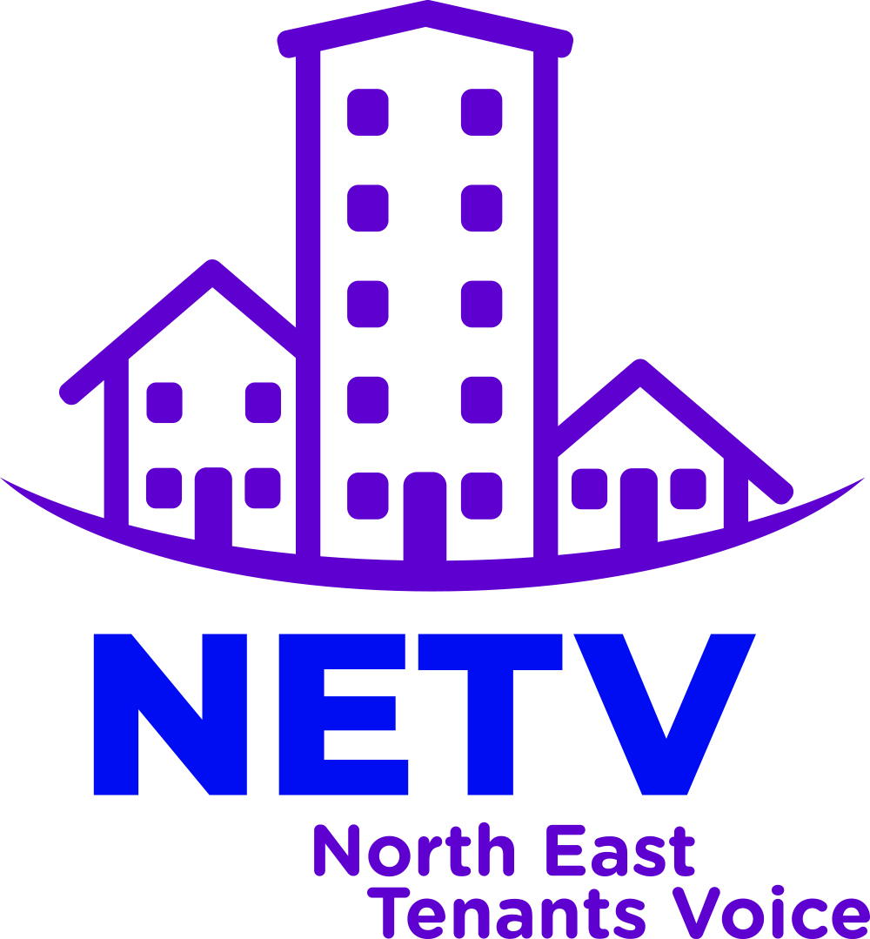

Building Safety Briefing

North East Tenants Voice
Introduction
Tpas has facilitated the creation of four specialist groups as sub-groups to the collective North East Tenants Voice to explore four key priority areas using the following three questions as a basis to form their response:
- What current action is being taken on this key priority?
- What resources can be accessed or what areas of the sector can help raise the profile of this priority?
- What role could NETV have in responding to the key priority locally, regionally and nationally?

This briefing paper comprises of the findings produced by the ‘Improving the quality of homes, neighbourhoods and Building Safety’ specialist sub-group.

- What current action is being taken on this key priority?

Quality of Homes
Due to the pandemic, many house services such as renovations, home improvements and non-emergency repairs have been placed on hold due to national and regional lockdowns and restrictions. With restrictions easing off further and full legal Covid restrictions being lifted on 19 July 2021, these works are being resumed but we need to be mindful that there is a large backlog that will need to be reduced and tenants should be informed of how this will be done by their landlord.
Neighbourhoods
Similarly to the quality of homes, neighbourhood improvements and works such as garden maintenance were placed on hold but again, are resuming, presumably with an extensive backlog.

Building Safety
Essential building safety priorities such as gas safety checks continued throughout the pandemic and housing repairs and maintenance staff were still actively dealing with issues around fire safety as a lapse in the delivery of these types of repairs would put a building and its residents at risk.

Learning from the Sector
Social Housing White Paper

In the Hackitt Review of Building Regulations and Fire Safety, a charter was developed to set out what social housing tenants should be able to expect, such as:

- To be safe in your home
- To know how your landlord is performing
- To have your complaints dealt with promptly and fairly
- To have your voice heard by your landlord, etc.

Health and Safety Executive

The HSE are in the process of setting up a tenant group to help shape and build the Building Safety Regulator.

Tpas

They’ve been working on a group to develop framework for engagement strategies around fire safety.

Landlords

Bernicia build homes to meet the Decent Homes Standard and they have a 5 year strategy to build 600 units by 2025.

In 2019/20 Bernicia home improvements consisted of:
- 659 aids and adaptations installed.
- 467 renewed
- 317 roof covering
- 298 bathrooms
- 252 heating systems replaced or upgraded
- 1137 electrical upgrades
- 49 windows and doors
- 204 wet rooms.

Bernicia’s housing team carried out 196 estate inspections pre-Covid. They have a Community Investment Fund for community projects

Your Homes Newcastle (YHN) for ensured there was no dangerous cladding on their residential blocks and started a programme of works to replace internal fire doors and front doors for flats in high rises with FD30s doors with closing devices which ensures the door closes behind a tenant if they had to evacuate due to a fire and the seal would expand to stop smoke leaking from and into the property.

YHN installed automatic closing devices onto the bin chutes which when smoke and fire is detected in a bin below the chute, these slam shut to stop the fire spreading up the chute and localised sprinklers put the fire out. We also installed thermal imaging cameras which staff can look at remotely and see what the temperatures are and this can be relayed in real time to the fire service to keep them up to date with changes that could be life threatening to themselves or tenants.

Finally YHN installed AOV (automatic opening vent) systems to all our high rises and these open automatically to let smoke out in the event of a fire to create safe, smoke free escape routes and access for the fire service.

- What resources can be accessed or what areas of the sector can help raise the profile of this priority?

- Social Housing White Paper
- Tenant voice groups who are currently or going to touch upon and work around fire and building safety
- Fire Service
- MHCLG
- Landlords
- CIH
- MP’s/Councillors

- What role could NETV have in responding to the key priority locally, regionally and nationally? Key recommendations:

- Dedicated group of tenants to lead talks, promote fire and building safety, undergo training, etc.
- Fire/Building Safety Champions in NETV
- Meet with local MP’s/Councillors to raise awareness
- Close working relationship with our local Fire Services

